Browsing History and Notepad Parser

User Guide

**Introduction 3**

**Getting Started 3**

Installation 3

Setup 3

**Usage 3**

Basic Usage 3

Advanced Usage 3

Command Reference 3

**Configuration 4**

Config File 4

Environment Variables 4

**Troubleshooting 4**

**FAQ 4**

**Glossary 4**

**Appendices 4**

# Introduction

In the world of Digital Forensics, it is known that there are multiple ways through which evidence may be hidden or abstracted away, one of which is to *not* save content made in a text-editor such as Notepad, so as to avoid creating a file that may be searched and viewed. It is also known that there are often remnant traces of activity that can point to some incriminatory evidence, e.g. the browsing history of a defendant.

Our tool is handy for fetching, compiling, and viewing the **unsaved Notepad content** and as well as **Edge and Chrome browsing history** on Windows 11 machines.

# Getting Started

## Installation

Requirements:

* Windows 11/10
* Python 3
* pywin32 (python library)
* cryptography (python library)
* sqlite3 (python library for SQL)

To install the python libraries, open Command Prompt, and enter:

pip install cryptography

pip install pywin32

pip install sqlite3

For the respective libraries.

## Setup

1. Open *File Explorer*
2. Move “**HistoryParser.py**” to a directory of your choice.
3. Go to that directory, click on the **directory-path field** at the top, and enter “cmd” (this should open Command Prompt in that directory)

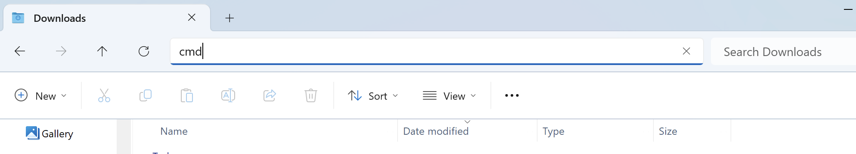

1. Enter “.\HistoryParser.py”

A window should open– the tool is now running!

# Usage

## Main Menu

Upon opening, you will see the main menu with 2 buttons.

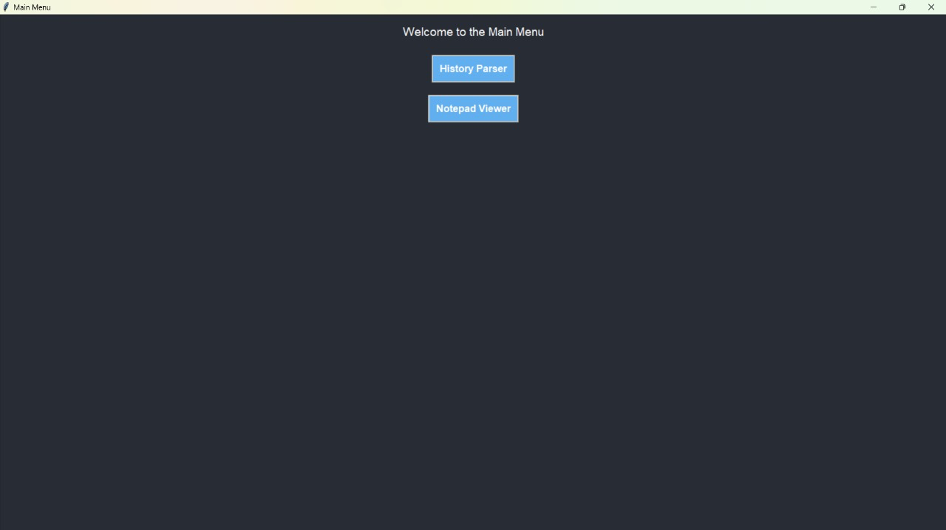

You may click on either “**History Parser**” or “**Notepad Viewer**”

## History Parser

Upon clicking “**History Parser**”, you may see a screen similar to the one shown below:

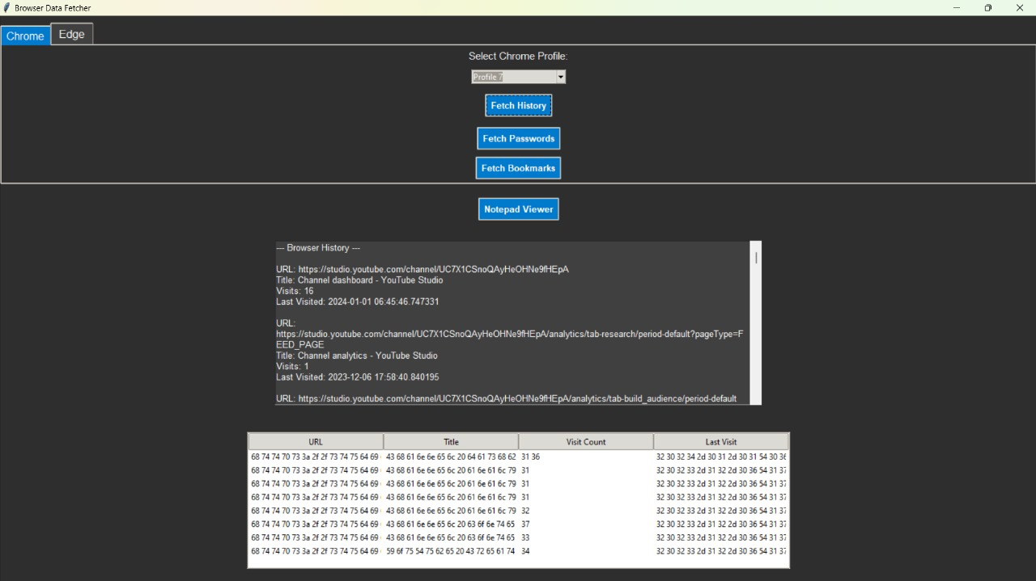

At the top, there are two tab selectors (“Chrome” and “Edge”) for you to switch the browser to fetch the history data of.

Inside the tabs, there is first a dropdown menu.

# Troubleshooting

Contact Muhammadd.khalidkarim@gmail.com

# FAQ

Q: You did this all by yourself?

A: Effectively yes.